Computer Network: Experiment 3.2

Name: Rithvik Rajesh Matta
SRN: PES2UG23CS485
Section: H

Chat Application:
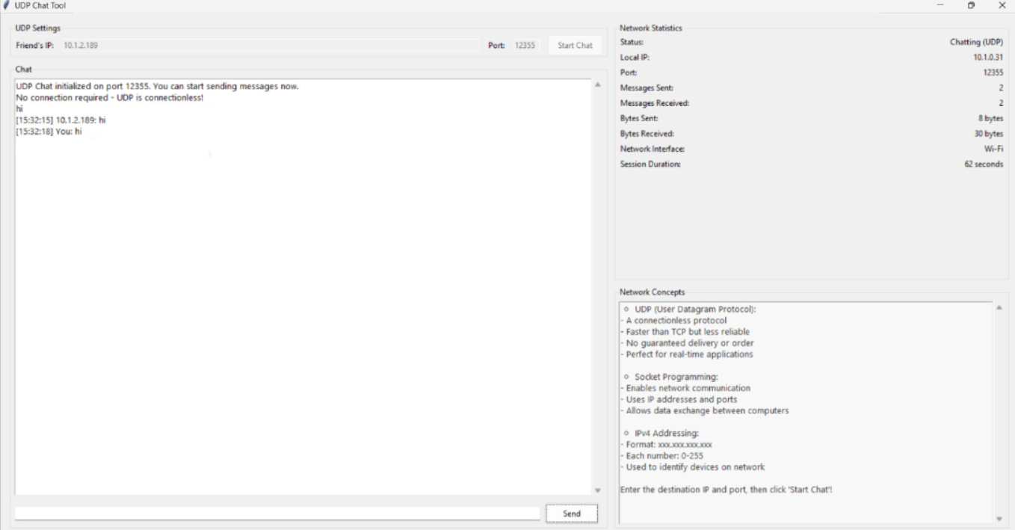

Wireshark:
